LAB ASSIGNMENT: 1

Lab: "Help the Rat Escape the Underground Pipes"
Terry the rat is trapped in a vast underground pipe network. The pipes connect junctions, and each pipe has a travel cost representing how hard it is to crawl through (longer pipes or blocked paths cost more time). Your task is to write a program that helps Terry find a path from his starting junction to the cheese hidden somewhere the network. in

Your program should:

Explore paths where Terry always tries to go deeper into unexplored pipes before checking others.
Explore paths where Terry always checks all nearby pipes before moving deeper.
Find the path with the lowest total travel cost.
Improve the search for the lowest-cost path by using a map showing the straight-line distance from each junction to the cheese as a guide.

Input:

Number of junctions and pipes.
For each pipe: two junctions connected and the travel cost.
Coordinates of each junction (for estimating straight-line distance).
Starting junction and target junction.

Output:

The path Terry takes for each exploration strategy.
The total cost of each path.
How many junctions Terry visited in each case.

INPUT:
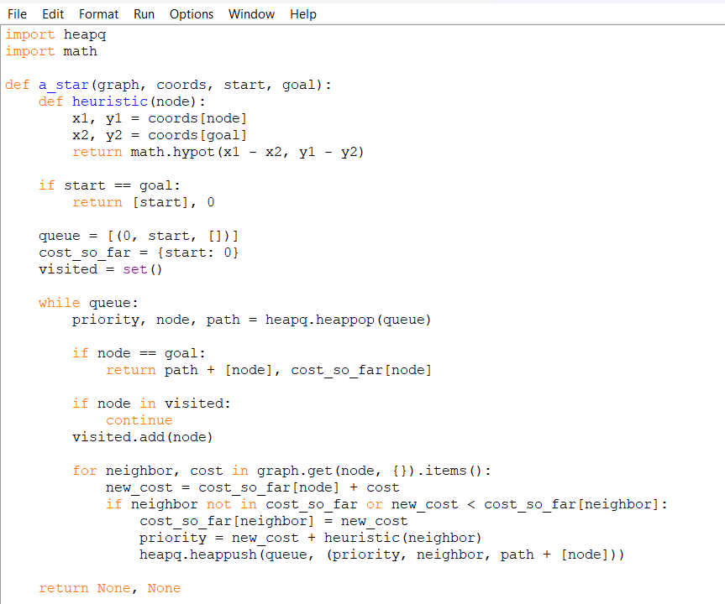
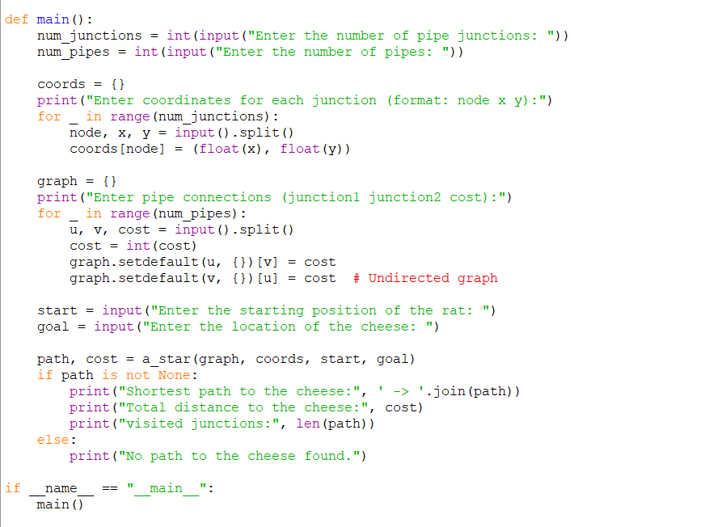
OUTPUT:

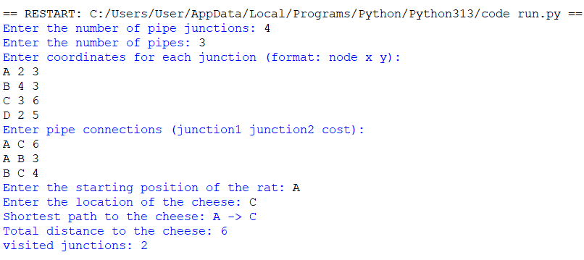

CODE:

import heapq
import math

def a_star(graph, coords, start, goal):
def heuristic(node):
x1, y1 = coords[node]
x2, y2 = coords[goal]
return math.hypot(x1 - x2, y1 - y2)

if start == goal:
return [start], 0

queue = [(0, start, [])]
cost_so_far = {start: 0}
visited = set()

while queue:
priority, node, path = heapq.heappop(queue)

if node == goal:
return path + [node], cost_so_far[node]

if node in visited:
continue
visited.add(node)

for neighbor, cost in graph.get(node, {}).items():
new_cost = cost_so_far[node] + cost
if neighbor not in cost_so_far or new_cost < cost_so_far[neighbor]:
cost_so_far[neighbor] = new_cost
priority = new_cost + heuristic(neighbor)
heapq.heappush(queue, (priority, neighbor, path + [node]))

return None, None

def main():
num_junctions = int(input("Enter the number of pipe junctions: "))
num_pipes = int(input("Enter the number of pipes: "))

coords = {}
print("Enter coordinates for each junction (format: node x y):")
for _ in range(num_junctions):
node, x, y = input().split()
coords[node] = (float(x), float(y))

graph = {}
print("Enter pipe connections (junction1 junction2 cost):")
for _ in range(num_pipes):
u, v, cost = input().split()
cost = int(cost)
graph.setdefault(u, {})[v] = cost
graph.setdefault(v, {})[u] = cost # Undirected graph

start = input("Enter the starting position of the rat: ")
goal = input("Enter the location of the cheese: ")

path, cost = a_star(graph, coords, start, goal)
if path is not None:
print("Shortest path to the cheese:", ' -> '.join(path))
print("Total distance to the cheese:", cost)
print("visited junctions:", len(path))
else:
print("No path to the cheese found.")

if __name__ == "__main__":
main()

